| Date | 22/06/2025 |
| --- | --- |
| Team ID | **LTVIP2025TMID48146** |
| Project Name | iRevolution: A Data-driven Exploration of Apple's iPhone Impact in India using Tableau |
| Maximum Marks | 4 Marks |

**Empathy Map Canvas:**

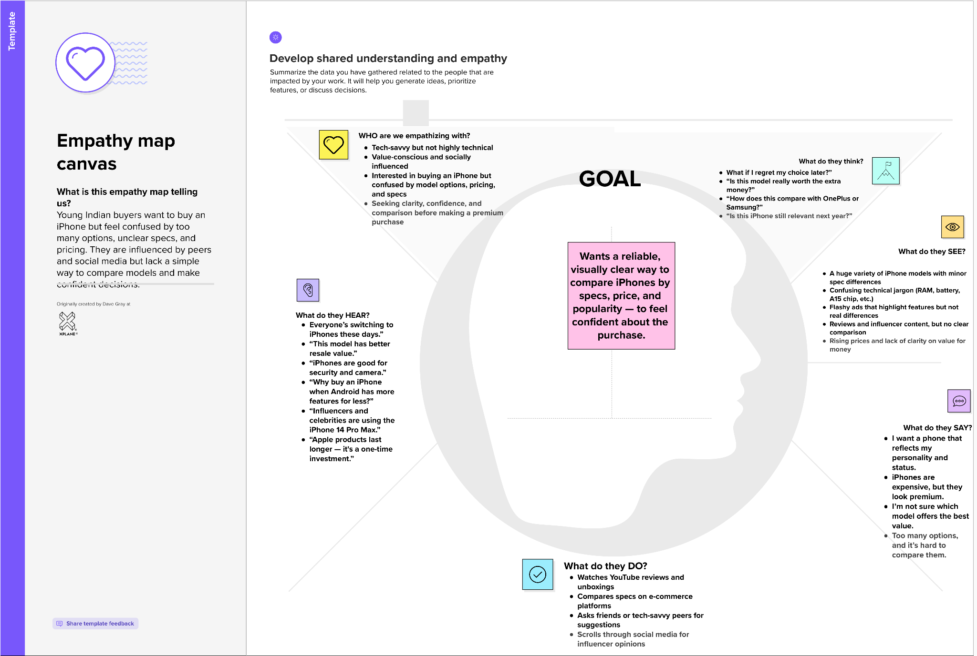

The empathy map helped us understand the real challenges faced by young Indian iPhone buyers. It revealed a gap between interest and informed decision-making — users are eager to buy but lack clarity and confidence. This insight guides us to design a data-driven, visual solution that simplifies comparison and empowers users to choose the right iPhone for their needs.